# CHALLENGE-2

Write a bash script to find the latency from the sample nginx log file.

Bash script should only only print the latency.



Steps:

Copied file from windows to linux

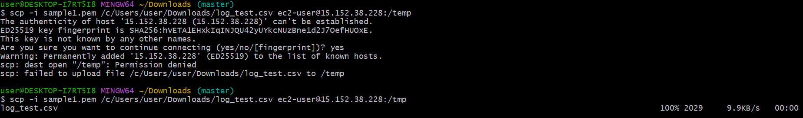

Now we can in the remote server that file will be copied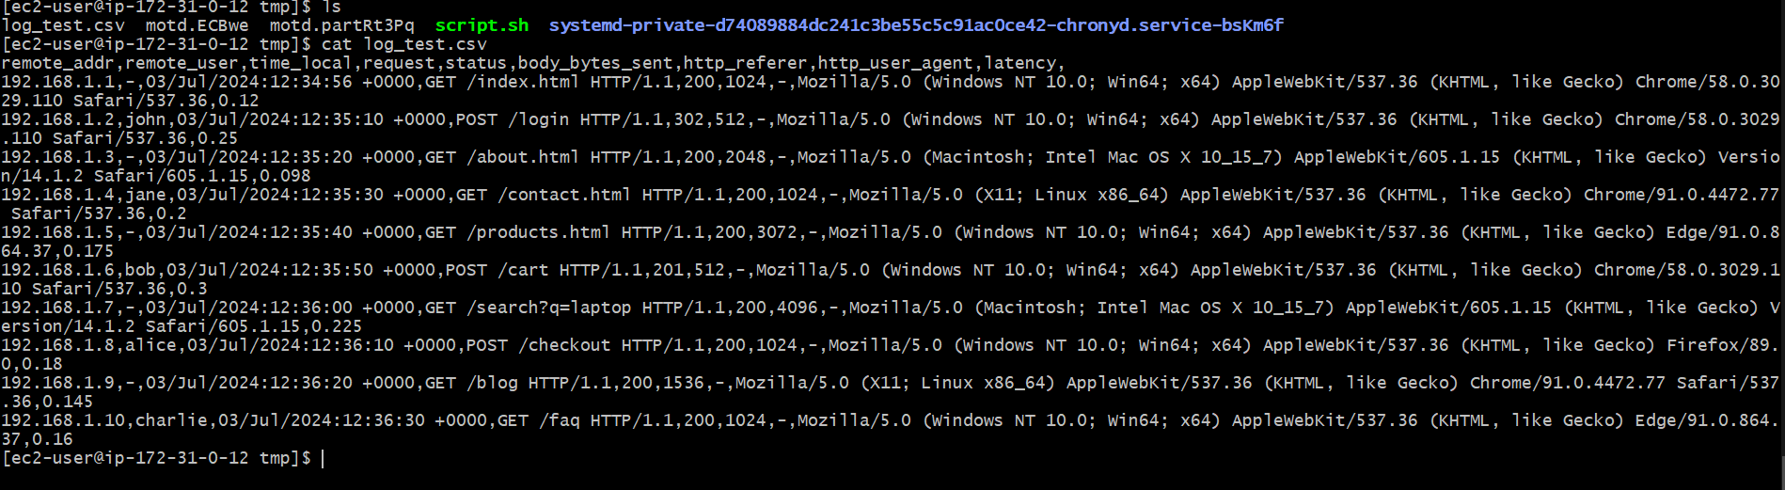

Creating the Bash script for printing only latency

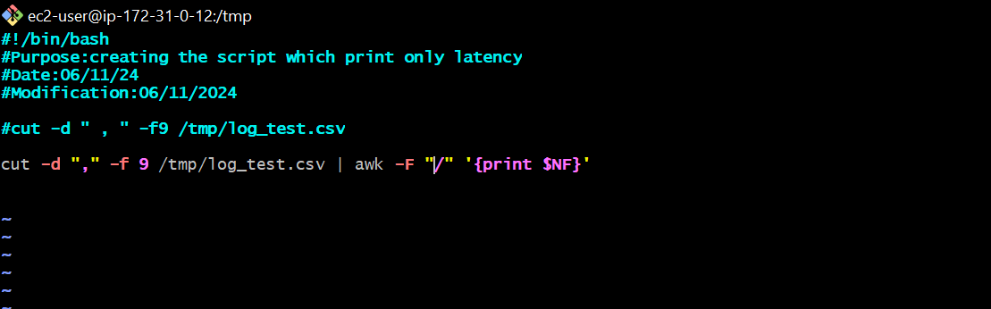

Saving the file

Giving the permissions: chmod 755 script.sh

Output:

